**Vi Editor-Assignment**

Q 1) invoke the vi editor with a filename

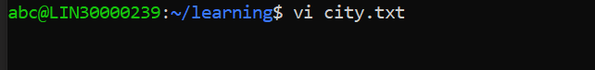

Q 2) Type a few lines(at least 10) in the editor. Let one or more lines contain the words given below.

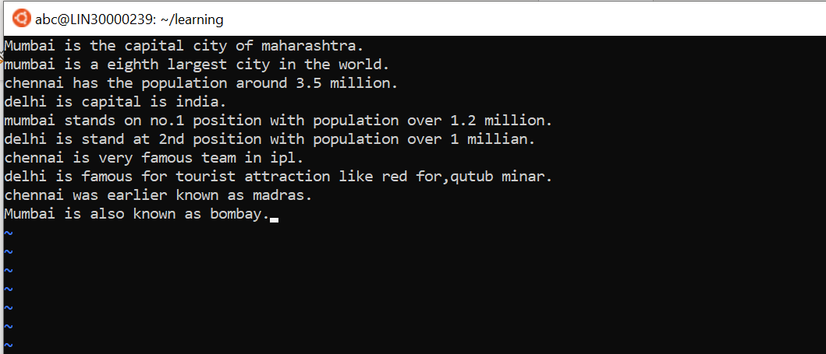

Q3) Save the file without exiting the editor

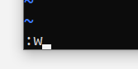

Q4) Navigate quickly to the beginning & end of the file

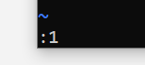

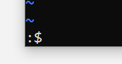

Q5) Delete first two lines & copy it after the last line.

Use 2dd to delete 2 lines & p to paste

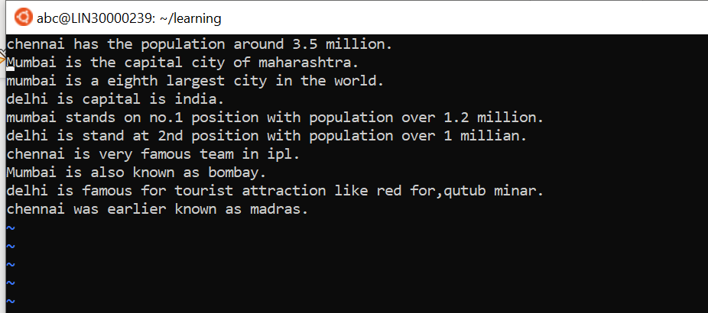

Q6) Now Copy the last two lines & paste them before the first line.

By using 3yy and p

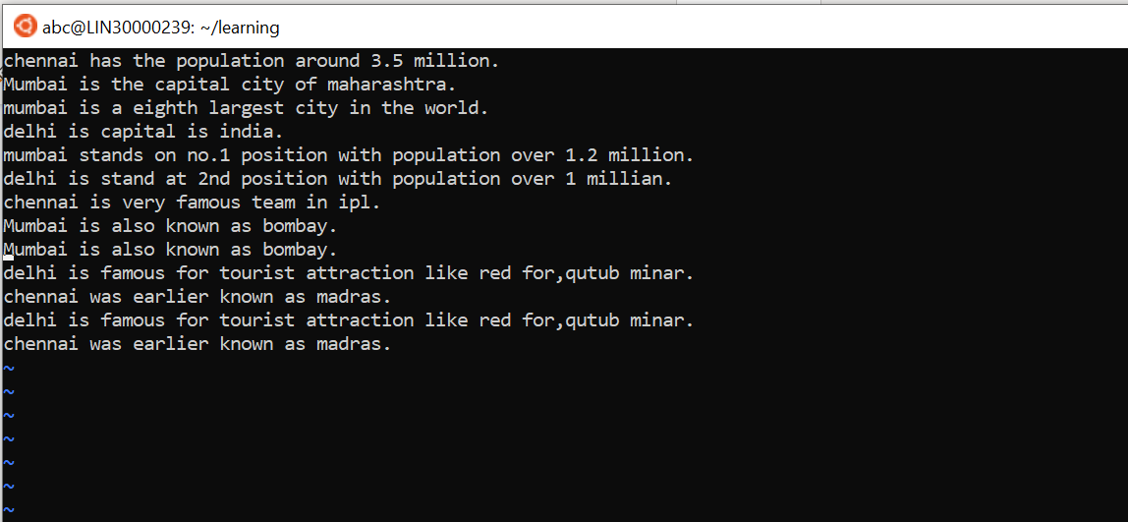

Q7) Combine last two lines of the file in a single line.

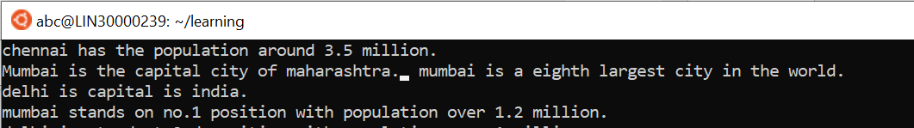

Q8) How will you insert a line before the first line?

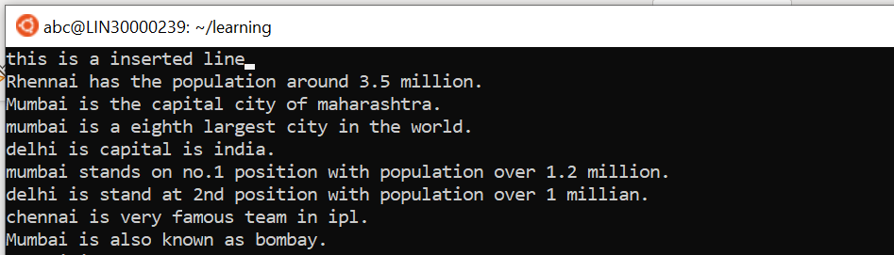

Q9) How will you paste a yanked buffer before the current line?

Ans- by using p

Q10) Search the document for a string “delhi”

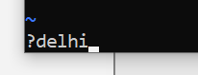

Q 11) Replace a single occurrence of “delhi” with “Mumbai”

Ans- :/delhi/mumbai



Q 12) Replace all occurrences of “delhi” on a particular line with “Mumbai” using one command.

Ans. :2s/delhi/Mumbai/g

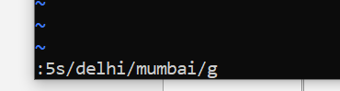

Q 13) Replace “delhi” with “mumbai” for the entire document using one command.

Ans. :%s/delhi/mumbai/g

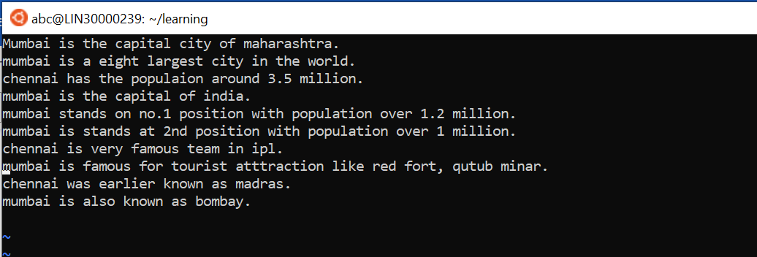

Q 14) Replace all occurrences of “delhi” with “mumbai” for part of a document (e.g. line number 13 to 37).

Ans. à :8,14s/delhi/Mumbai

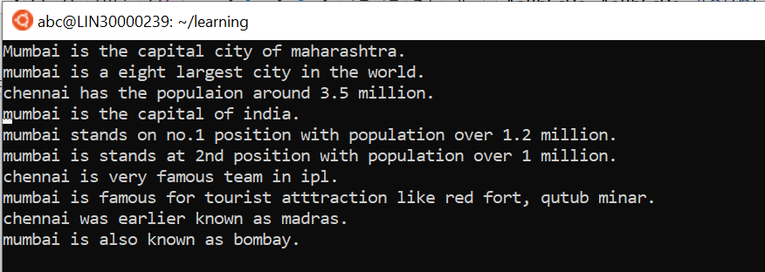

Q 15) Undo the above command.

Ans. Press u

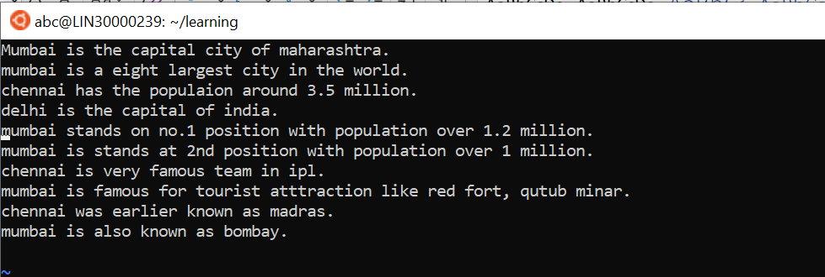

Q 16) Replace only the first occurrence of “delhi” with “mumbai” in each line, for part of a document (e.g. line number 8 to 14).

Ans. :2,9s/delhi/Mumbai

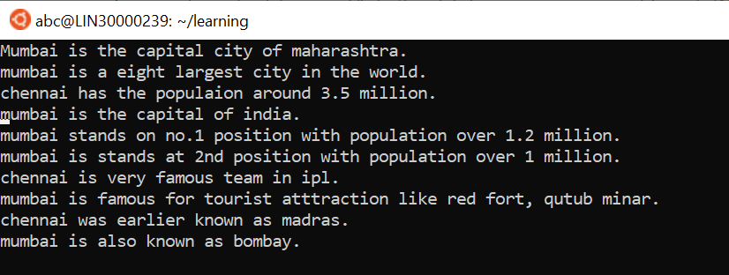

Q 17 ) Undo the above comment. Redo it. Undo it again.

Ans. press u, then press Ctrl+R, then again press u.

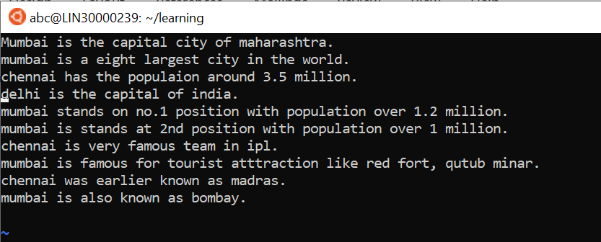

Q18 ) Replace all occurrences of “delhi” with “mumbai” for complete file interactively.

Ans. :%s/delhi/Mumbai/gc

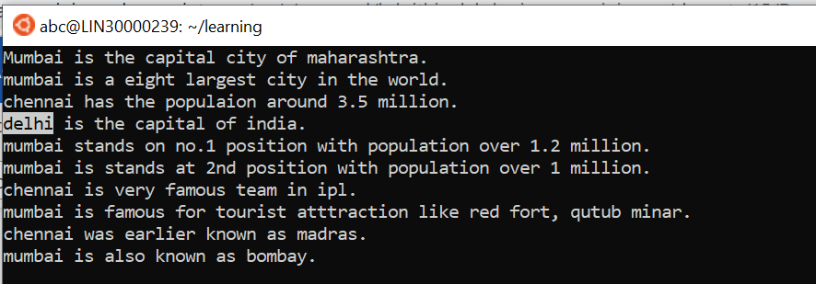

Q19 ) Search for a word backwards. Loop through all matches.

Ans. :?delhi

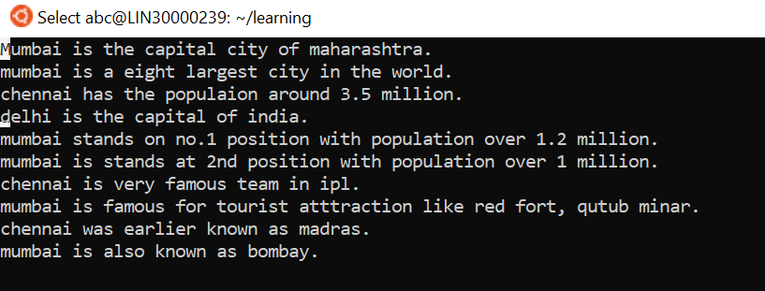

Q 20 ) Search for a word forward. Loop through all matches.

Ans. :/delhi

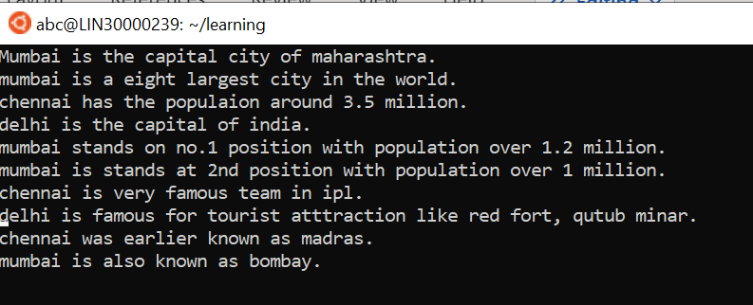

Q 21) Join two lines together.

Ans . cursor place to the you want to join and then press J.

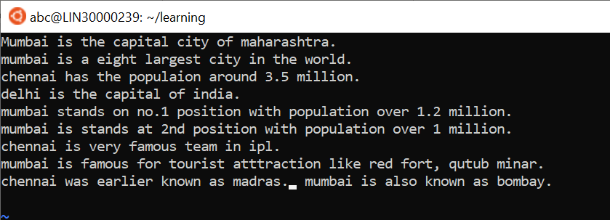Q 22 ) Enable line numbering and then disable it.

Ans. To enable :set nu & to disable :set nonu

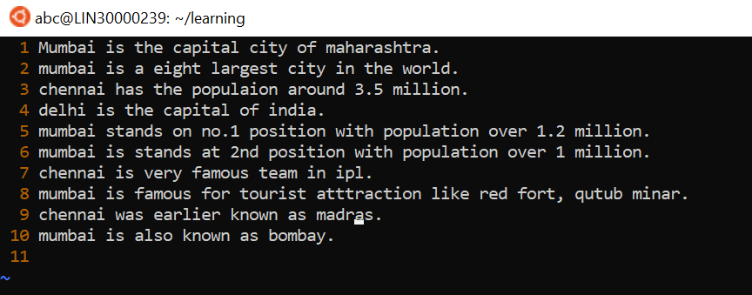

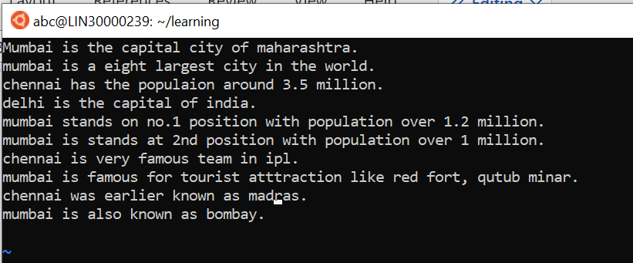

Q 23 ) Make the search case insensitive.

Ans . :set ic

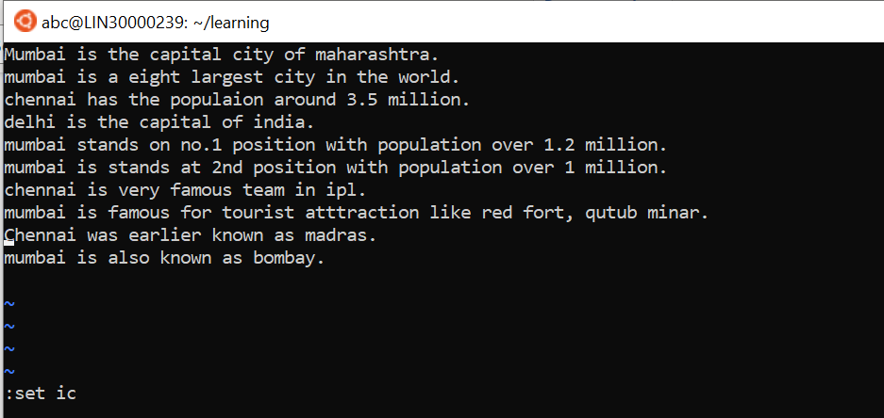

Q 24 ) Delete 4 lines (and then paste them somewhere else)

Ans. use 4dd then paste it somewhere else using p

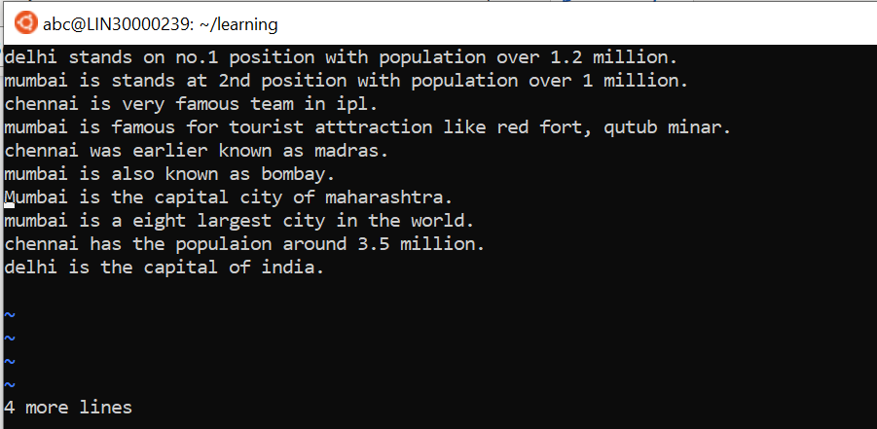

Q 25) What is the command to delete part of the line starting from the current cursor position?

Ans. d$

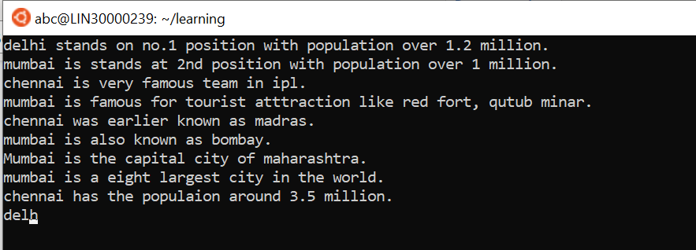

Q 26) What is the command to delete the current word?

Ans. dw command

